Betty’s Bay
Neighbourhood Watch

Emergency Number: 072 015 5729
Coordinator: 082 528 6053
Email Address: bbaynhw16@gmail.com

BBNW INFO BULLETIN 5 OF 2020

Dear members

OPENING STATEMENT

1. I would like to thank everyone for their inputs, suggestions and crime reporting. I thank those too, who have contributed to our coffers. We could be more effective if more passive members became active members.

OUR STATUS

2. Premises/plots/houses 2953
Open plots (before lockdown) 1043
Developed plots 1910
Permanent owners/tenants 505
Holiday homes 251
Not sure whether homes are permanent or holiday 1144
Total member households 730
Total members on database 1040
Members on email 744
Members on WhatsApp 109
Members on Telegram 467
Passive members 576
Potential eyes and ears 1040

There are many vacant plots that have become building sites and we would like to know where they are so we can establish who is building and who is living there while the building is going on.

As you have probably deduced that there are many homes that we don’t know whether they are permanent or holiday homes. This is important information and street reps and area reps can assist.

STREET AND AREA REPS

3. As you are aware, we rely on information to keep ourselves safe. All passive members are our eyes and ears of the neighbourhood. There are members that go for walks and walk their dogs that could become more actively involved in reporting changes in their streets and areas. We therefore urge you to become more actively involved as street reps or area reps.

NEW AND OLD RADIOS

4. The new radios are proving to be much better and more effective as a communication tool. Thank you to all who made this possible. Each active member of the BBNW who has a cellphone radio, pays for the monthly cost of the radio out of their own pockets as we as the neighbourhood watch do not have funds available on a monthly basis to pay for the cellphone radio contracts.

5. The old radios will be maintained and issued to area controllers for area patrols and special operations with security companies.

CAMERA SYSTEMS

6. We invited Jaco Van Wyk from NAVIC to give us a presentation on the value and importance of being part of the system in terms of keeping us informed now and in the future. This system was agreed on and adopted as one of the tools BBNW and the security cluster would pursue in the interest of community safety. It was also realized that funding and practical execution would have to be discussed in depth and solutions sought before implementation. It was also agreed that the security bosses and part of the executive of BBNW would meet to discuss the way forward. This too is going to be an expensive and ongoing cost, and funding will have to be secured for the radios and camera systems in the future. Advice and recommendations are welcome.

CRIME IN GENERAL

7. Crime is definitely on the increase. We advise all residence to communicate with their respective security companies to upgrade old systems and replace old batteries. It is now a fact that the criminals have devised ways around old systems. My personal opinion to add value to your security system is to add an IP, PTZ camera. You could even share your camera with us for more intel gathering and permanent eyes on certain areas.

8. We also realized that Crime Scene Information Data coordinator (Gerald) would need help in compiling data sheets and visiting victims of crime. My request to all victims of crime to please contact us after the police have left and talk to us so that we may establish and work on more detailed information. This is very important in determining trends and forecasting criminal activities. Even if you have not reported the crime to the police, give us a call so we can add your data to our database.

REPORTING ON CRIME

9. We have an obligation to keep you informed on all matters, hence the bulletins. However, we cannot give too much information on the groups and via email. WE ARE ONLY AUTHORIZED TO GIVE CRIME STATS THAT INDICATE TYPE OF CRIME AND AREA. The rest of the information we have is privileged to us for obvious reasons.

10. On our BBNW emergency and crime reporting groups, please do not ask questions or report on suspicious activities or ask to add someone or question crime states etc. ONLY EMERGENCIES AND REPORTING CRIME THAT IS ON THE GO. If you need to know anything else, contact me on 0829281260 or Rob 0825286053.

11. NB. We do not report poaching activities on our emergency groups as we have other dedicated groups on WhatsApp format for this.

a. Sea Watch 082 994 9300
b. Betty’s Bay Marine Watch 083 383 1462
c. Marine Watch Overstrand 076 878 8860
d. DEFF Unclear at the moment
e. MAPU 060 907 2326
f. Cape Nature 082 453 0835

It must also be born in mind that all these agencies are connected to each other in some way or another and react or respond differently at different times and different ways. All our information and intel goes through one or more of these agencies every time you report an incident.

WORKING WITH SECURITY COMPANIES

12. Working with the security companies at night has made our collective efforts more professional and importantly strengthened of resources in the plight to prevent crime. It was also decided that different efforts would be planned to deter criminal activity or even apprehend criminals in the near future.

NEGATIVE ATTACKS ON OUR NEIGHBORHOOD WATCH

13. There is a group of people that are extremely critical of our efforts and what we do and how we do it. Mostly from ex neighbourhood watch members, ex whatever members and “know it all’s”. We are volunteers trying to take care of a certain element of community care in the safety and security environment. We are not perfect and we do not have all the answers, but we are out there trying in our own time with our own finances and our own resources mainly. When you encounter these negative people, be it in a Betty’s Bay forum/association, in the barber, at the shops or at a braai, help them to understand that they are not helping in any way shape or form by talking falsehoods about our BBNW.

GENERAL INFORMATION

14. Members of the BBNW were invited to do the basic security competency course so as to be better equipped to work with the security companies. It is something we will explore.

15. Patrols. Unfortunately, patrolling the village in vehicles is no longer a general option. We have learned how the criminals operate to determine our whereabouts and therefore we have to change tack. We have other means to achieve the same.

16. Emergencies. It was agreed that we as a partnership understood what constituted an emergency and would be able to cope with any emergency and know where to escalate it to.

17. We are working towards a platform where members within different zones would have a controller and that controller would be your first port of call in an emergency so as to cut down on reaction time. This is not yet in place.

18. A date was fixed for the last Wednesday of each month at 16:00 at Crassula Hall at a rate of R100.00 per meeting to be absorbed by the BBNW. One may request to be at these meetings to see who we are and how we conduct our business. There will also be an opportunity for you to ask questions.

LAND GRABS

19. This is an important and urgent matter to me. May I say that if anyone across Betty’s Bay see or hears of any structure going up on a plot, piece of land or backyard, please inform us immediately. This will be considered an emergency for now. We will then clarify and inform the correct authorities.

FINANCE

20. It has become clear that BBNW needs funds and the only way to do this is through donations from the residents and fund raising. With this said I would be more than happy to accommodate a group of volunteers dedicated to raise funds for us on a permanent basis.

The account details are as follow:
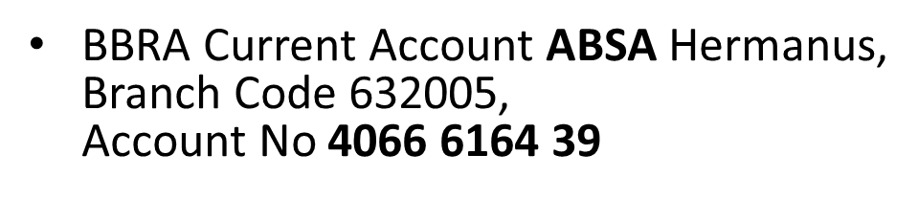

If you are going to make a contribution to the BBNW please state BBNW and your erf number (BBNW4233).

21. The BBNW is a dynamic and structured organisation designed to prevent crime in Betty’s Bay, however it can only work well if we all get involved.

Go you well and be safe.
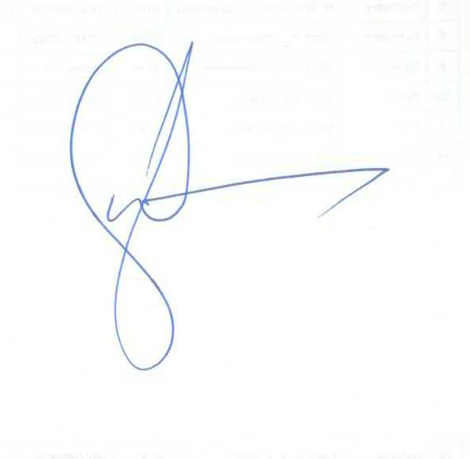
Wayne Jackson

0829281260
wayrayjack@gmail.com

STRUCTURE

 | SAPS |  |  |  |  |  | CPF  Jacques Oosthuizen |  |  |  |  |  |  |  |  |  | DoCS
DEFF  CN  LE  APU | Johan  Edward  Tristan  George |  |  | BBNW  Executive Committee  The Watch  Passive Members of Betty’s Bay  Eyes & Ears  Source of Intelligence/information |  |  |  |  |  |  |  |  |  |  |  | Sandown Bay  CULive  Bolt  ASK |  | Johan  Kobus  Freek  Johan
DEFF/CN/LE/APU |  |  |  | Wayne |  | Gerald |  |  |  | Zachie |  |  | Rob | Security Cluster

